**University of Rwanda**

**College of science and technology**

**School of ICT**

**Computer and software engineering**

**Level 3**

**Software Design and Development**

**PROJECT REPORT**

**PHARMACY MANAGEMENT SYSTEM**

**Members:**

**Iradukunda eric 220001417**

**Nkusi kevin 220002919**

Contents

**1.INTRODUCTION** 3

Purpose 3

SCOPE 4

Objectives 4

Definitions, Acronyms and Abbreviation 5

Reference 5

Overview 5

2.CURRENT SYSTEM 6

3.PROPOSED SYSTEM 7

3.1. Overview 7

3.2. Functional Requirements 8

3.3. Non-Functional Requirements 9

3.3. System Models 10

Scenarios 10

3.4.3. Object Model 22

3.4.4. Data Dictionary 22

3.3.4.1. Class Diagram 23

3.4. Dynamic Model 24

3.4.2. Sequence Diagram. 24

3.4.5. Supposed user interface 32

4. Glossary 34

# 1.INTRODUCTION

Now a day’s Information and communication technology (ICT) plays a great role in different fields or areas among thus Health care system belongs to this.

This leads to various studies and researches being conducted to selected health care facilities.

It is necessary to ensure a technologically appropriate, equitable, affordable, efficient, and environmentally adaptable and consumer friendly system, designed to fully utilize the ICT for the maximum benefit in the health care industry. Here computers have great relevant on storing data’s securely and ease access on them in short period of time. In order to exploit the ICT in health care system, Pharmacy management system is being build.

Pharmacy management system is robust, integrated technology.

Pharmacy management system deals with the maintenance of drugs and consumables in the pharmacy unit. The set-up of this pharmacy management system will ensure availability of sufficient quantity of drugs and consumable materials for the patient.

This will enhance the efficiency of clinical work and ease patient’s convenience, bearing in mind that in Rwanda is heading towards pharmaceutical care of patients. In addition, Pharmacy management system will be able to process drug prescription with ease. Pharmacy Management System will design to detect drug interaction.

In general, The Pharmacy management system is based on computer technology that gives service for users, managed by the pharmacist who give implementation of function relatively in effective times as well as will design for removing time wasting, saving resources, easy data access of the medicine, security on data input and data access by removing almost manual based system.

# Purpose

The pharmacy management system is built for the sake of ensuring effective and clear data saving and manipulating as well as neat work on the pharmacy medical products.

This refers the pharmacy management system project highly minimize time and resource by which, searching the medicine data you can get the data in quickest time. And almost the resources are wise used since most actions are done on the pharmacy system.

Some of the resources minimized include paper, manpower and related things. The other thing is for storing data in secure way.

A summarized list of drugs dispensed to patient can be viewed for monitoring purposes. Also, Pharmacy Management System will be able to generate report on the list of drugs dispensed in the polyclinic for a given time period. And there is a message alert for the user if the stock holding quantity reaches a low level. Thus, the pharmacist will need to replenish the drugs.

## SCOPE

With the development of specific and potent synthetic drugs, the emphasis of the pharmacist’s responsibility has moved substantially towards the utilization of scientific knowledge in the proper use of modern medicines and the protection of the public against dangers that are inherent in their use.

Pharmacists are employed in regulatory control and drug management, community pharmacy, hospital pharmacy, the pharmaceutical industry, academic activities, training of other health workers, and research.

In all these fields, their aim is to ensure optimum drug therapy, both by contributing to the preparation, supply and control of medicines and associated products, and by providing information and advice to those who prescribe or use pharmaceutical products.

# Objectives

It is the User-friendly application for Pharmacist which reduces the burden and helps to manage all sections of Pharmacy like Medicine management and Billing etc.

which improve the processing efficiency. It deals with the automating tasks of maintaining of Bills.

In Pharmacy, Billing management is the key process. Including safe data store about medicine as well as fast searching, delete and update of medicines.

The PMS(pharmacy management system) is easy for use so the user can do pharmacy actions without ambiguities.

The main Objectives of the Pharmacy Management System is making the pharmacy organizations computerized by creating neat work through minimizing or eliminating wasting of time as well as removing the resources such as papers for data saving since know a day is paper based, decrease malfunctioned works on the medical usage by giving correct information on each medicine.

# Definitions, Acronyms and Abbreviation

**Definitions:**

**\*User-friendly**

Is the way that the built system is not ambiguous which is clear for using the created software interface for manipulating actions or tasks. In the other way the proposed system is designed for human likable components in color, font and other related things.

**\*Manual based System**

The system that uses was paper based and arranged on the shelf through functionality of documents. Everything that is arranged, searched, updated and deleted is through humans only. In general manual-based system is un-computerized system which is tedious in its data arrangement for efficient work.

**\*Pharmacist**

The profession who has knowledge on the medicine usage, instruction for use those medicines for the particular diseases and other related things.

**\*Management System**

A system in which manage, organize, formulate data through a technical data structure arrangement.

**Definitions:**

PMS Pharmacy Management System

# Reference

[**https://www.w3schools.in/laravel**](https://www.w3schools.in/laravel) **,**

**https://github.com/erikunda77**

[**https://laravel-news.com/your-first-laravel-application**](https://laravel-news.com/your-first-laravel-application)

# Overview

The pharmacy management system is built in order to replace manual based system to computerize. Here system is expected to be efficient, useful and affordable on implementing tasks that is order by the pharmacy manager.

# 2.CURRENT SYSTEM

The current Pharmacy system were manually base system which is almost all works on the pharmacy organization is accomplished by papers.

Among thus Medicine data search in order to buy, audit, and other related works. And the other one is data security, the data’s can be accessed anyone who entered to the pharmacy house as friends, other Humans without the volunteer of the pharmacist.

The pharmacists work in tedious situation because of the upper reasons. Not efficient on arrange medicine on the shelf meaning arrangement method is difficult to take in mind.

In current system almost all pharmacies do not use computerized system but use computer for giving bills only for the sold medicine to the user. And use manual searching of medicine on shelf because of manual based system and there is nothing which gives alarm for the finished or sold medicine.

Also, there is a difficulty on store the data which wastes resources as well as time to retrieve the necessary data from the manually based data system.

So generally, the current system does not arrange medicine in systematic way, does not store the medicine appropriate data, security for the data is low, does not indicate how much medicine is needed and sold quickly and efficiently.

The pharmacy system will implement by the pharmacy unit of the organization.

At present, manual system is being utilized. This system requires the pharmacist to manually monitor each drug that is available in the pharmacy shelf.

This involves manually entry up on arrival of batches of drugs and upon drugs’ movement out of the unit, for example, dispensing to patients or product recall or loan to other clinics/hospitals. Upon a certain period, such as month, the pharmacist is required to generate reports on the movement of drugs.

This is to monitor the justification of ordering in order to replenish the already diminishing stocks. In addition, ordering of drugs is also being done manually. Significant amount of time is allocated for writing order as one needs to go through the stocks’ balance and rough estimate of the amount to order. This usually led to mistakes as one May over or under-order.

Thus, in this aspect, the workload of a pharmacist increases.

As a result, sometimes, patient care, in terms of counseling, is compromised due to time constraints.

# 3.PROPOSED SYSTEM

The pharmacy management system is design based on computer science students in order to illuminate the problem of the current system which provided by the system involved all the pharmaceutical employees of the pharmacy.

This accessibility of the information will be great advantage as it reduced further medical errors associated with physicians and nurses. The system handles all aspects of the inventory control function.

It allows the pharmacist to receive new batches of drugs, delete obsolete drugs and modify the current dosage and identification of drug in the database. Furthermore, the system eases the process of stock replenishment.

On the other hand, PMS enables dispensation process. It stores all the Drug details and Pharmacist information. A summarized list of drugs dispensed to the patient can be viewed for monitoring purposes. With the proposed system, the pharmacist will be able to monitor the movement of the drugs with ease. The system is design to track the entry of refresh batches of drugs, be it upon orders from manufacture or loan from the hospital/clinics.

It also monitors the drug’s movement history, thus leads to better inventory management of money allocated for the purchase of drugs. Compared to the current manual system, the implementation of Pharmacy management system will reduce the time spent for paperwork, leading to concentration on improving pharmaceutical care of patients, especially emphasis on patients’ medication monitoring. It will be greatly embraced by the pharmacy profession as it is one giant leap towards pharmaceutical care of patients.

# 3.1. Overview

The pharmacy management system provides functions on identify medication usages instruction, minimize human errors in medication safety, facilitate accessibility of drugs’ information and information management among employees, providing optimal drugs movement in pharmacy unit, enable reports with in significantly short period of time, despite simultaneous usage of database for the purpose stated above.

The system will solve the problem of the current system by minimizing time wastage and reduce resources which simply change manual-based system to computerized system.

# 3.2. Functional Requirements

There are functions done by the system such as: store the necessary information of drugs, prepare bill for the medicine, give week reports, easily searching of medicine, Update, delete and save data’s of medicine.

**\*Generate report**

the pharmacy management system generates report weakly on information about the drugs and it exports the information as output document.

**\*Store the necessary information of the drugs**

The PMS (pharmacy Management system) stores the detail information about each medicine including Actual name, cost of medicine and how it is importance and for which diseases is required. Since the information for each drug were required in some cases like the use of drugs, when use drugs and for whom is given.

**\*Searching medicine and other data**

The PMS has easily searched of medicine which shows in which shelf is put and the behavior of the medicine. The searching process is based on the name of the give data or the identification of the item. Here when the user searches the item on search bar the related things were displayed in the screen and can select the actual item that the user needs.

**\*Altering pharmacy data in the system**

Changing medicines to another because of medicine outdated, modifying the saved medicine data for incorrect data, deleting of data of the pharmacy can be done on the system.

**\*Currently Support English language**

The system supposed work on primarily in English

# 3.3. Non-Functional Requirements

This pharmacy management system is able to operate in the following characteristics.

**\*Usability:**

Any familiar in using windows operation can operate the system since it has user friendly user interface. Which have the instruction menu’s how to use it which self-directive application then can be used the system without ambiguity.

**\*Reliability:**

The pharmacy system is available based on the user needs, can work properly, and do transactions efficiently including safe data management of the pharmacy. The pharmacy system is password protected to change things on the system. Here the pharmacist manager control over the system by login to the pharmacy system. Any user can’t use the system but the guest user can see on general properties of the pharmacy and medicines without password. As result data is protected and controlled by only the administrator

**\*Performance:**

The pharmacy management system operates its function in small amount of time which is less than four seconds and can be accessed by one user at a time or concurrently. To access the user must first login to the system which must have the pharmacy system privileged.

**\*User-Interface:**

the user interface is friendly which is easy to use. And having attractive frame structure which is prepared in assumption with other related systems. Also, the user can change him/her user favorite interfaces that Is available in the system.

**\*Operation:**

the pharmacy management system is operated and controlled by the pharmacy manager for safe work.

**\*Supportability:**

This pharmacy management system operates in any version of windows operating system. The system can be easily maintained by the manager of the pharmacy system by using the prepared documents of the system for easy maintenance. Other ways it is maintained by the system developers for corrective and other heavy problems.

**\*Implementation:**

we used Laravel MVC framework to implement the system along with MYSQL database.

# 3.3. System Models

The pharmacy management system is based different model view to represent the system in understandable way such as in scenarios, use case models, object models, Activity diagrams, and sequence diagrams.

# Scenarios

The pharmacy management system registers medicine, store on the database again accessed when needed, remove when obsolete, modified when additional information is exist, Export reports for weekly sold medicine, altering when medicine items are low and when are expired and billing for sold medicine.

Scenario 1:

The pharmacy manager and the Pharmacist can get information on the pharmacy by navigating the pharmacy management system. From the system page can see about the Medicine sell on the pharmacy, about the organization of the pharmacy including basic information. Through this the pharmacy management system can display different information about the organization effectively and efficiently in short period of time.

Scenario 2:

The pharmacy manager can control over the system such as record medicine information store on the system and again retrieve for data see, delete, update, and print also the pharmacy system controller can see reports on the medicine in weekly, and monthly as the user needs this is all about the function done by the system and do the pharmacy manager. The following is scenarios explain more.

**Scenario name: GetInformationAboutPharmacy**

**Actors**: -Pharmacy manager, pharmacist

Flow of Event:

1. The pharmacy manager initiates the system.

2. The system displays the first page.

3. The first page consists of menu’s Medicine, and About pharmacy

4. The pharmacist or the pharmacy manager enters credentials to login to system

5. System displays the medicine available on the pharmacy with cost and purpose.

6. The pharmacist or the pharmacy manager all see their dashboard depends on everyone permissions and roles

**Scenario name: changeMedicineData**

**Actors:** -Pharmacy manager

Flow of Event:

1. The pharmacy manager initiates the system.

2. The system displays the first page.

3. The first page login Menu’s

4. the pharmacy manager enters login menu

5. the system displays login form to enter the username and password.

6. The pharmacy manager prompts username and password on available fields that the system displays. 7. The system displays Main admin page. 8. Go on the settings and change Medicine Data

9. Save the changes.

**Scenario name: getNotificationOnMedicine**

**Actors:** -Pharmacy manager

Flow of Event:

1. The pharmacy manager initiates the system.

2. The system displays the first page.

3. The first page login Menu’s

4. the pharmacy manager enters login menu

5. the system displays login form to enter the username and password.

6. The pharmacy manager prompts username and password on available fields that the system displays. 7. If there are low medicine items the system displays alert

**Scenario name: ChangeLoginPassword**

**Actors:** -Pharmacy manager

Flow of Event:

1. The pharmacy manager initiates the system.

2. The system displays the first page.

3. The first page login Menu’s

4. the pharmacy manager enters login menu

5. the system displays login form to enter the username and password.

6. The pharmacy manager prompts username and password on available fields that the system displays. 7. The pharmacy manager go on settings 8. Enter the change password menu

9. enter the old password

10.enter the new password

11.re-enter the new password

12.Then press the change login button.



**3**.4.2. Use case model



**pharmacist**



**Pharmacy**



**manager**



1.**Use case description for Login to System**

**Use case name:**  Login to System

**Summary**  System validates the user

**Actor** the Pharmacy Manager

**Precondition** the login page must be displayed

Main sequence:

1. The pharmacy manager going to the login menu and click on it.

2. System prompts the user for username and password

3. The pharmacy manager inserts username and password to the fields.

4. System checks the username and password.

5. If the input were valid value, then system will display general system of the pharmacy system.

Alternative sequence:

Step 5: if the username or password is not correct, the System displays an Error message. And prompts for the correct username and password.

Step 1-4: if the user clicks on cancel, the system will go on the pharmacy Navigation page.

Post condition: username and password of the user is Validated.

1. **Use case description for Info about pharmacy**

**Use case name** GetInfoAboutPharmacy

**Summary**  Makes the user to understand about the pharmacy.

**Participating Actors** Pharmacy Manager, Pharmacist

Flow of event

1. The pharmacy manager initiates the system.

2. The system displays the first page.

3. The first page consists of menu’s Medicine, and About pharmacy

4. The pharmacist or the pharmacy manager enters Medicine menu

5. System displays the medicine available on the pharmacy with cost and purpose.

6. The customer or the pharmacy manager enters About pharmacy

7. System displays about the organization services and establishment.

Alternative sequence

Step 5-7: if the user enters cancel the pharmacy management system will Stop the operation.

**Entry condition** The pharmacy manager system must be on process or opened.

**Exit condition** The pharmacy manager making Transaction could not be processed.

1. **Use case description for Add New Medicine Data**

**Use case name** AddNewMedicineData

**Summery** successfully record new medicine data

**Actor** Pharmacy Manager

**Dependency** include login into the system

Flow of event

1. The pharmacy manager login into the system.

2. Go to Dashboard.

3. Select Add new medicine option.

4. The system display record form

5. Then the pharmacy manager fills the form that the medicine data has.

6. Then save the medicine that fills in step 5.

7. System checks the data entered whether correct or not

8. If the data’s input were correct then system saved it into the disks.

Alternative sequence

Step 7: If the input form has error the system displays “Saving error” message

Step 1-7: if the user enters cancel the pharmacy management system will Stop the operation.

**Entry condition** the pharmacy manager system must Be on process and login to the system.

**Exit condition** The pharmacy manager making transaction could not be processed.

1. **Use case description for Update Medicine Data**

**Use case name** UpdateMedicineData

**Summery** successfully updated medicine data

**Actor**  Pharmacy Manager Dependency include login into the system

Flow of event

1. The pharmacy manager login into the system.

2. Go to the system settings and menus.

3. Select on medicine records option.

4. The system display the available medicines that is recorded before

5. Then the pharmacy manager selects the medicine that he/she wants update.

6. Then press the update from available options.

7. The system displays the medicine data that is recorded before.

8. The pharmacy manager change the data that displayed in the form

9. Save the updated fill form.

10. System checks the data entered whether correct or not

11. If the data’s input is correct then system saved it into the disks.

Alternative sequence

Step 10: If the input form has error the system displays “Updating error” message

Step 1-10: if the user enters cancel the pharmacy management system will Stop the operation.

**Entry condition** the pharmacy manager system must be on process and login to the system.

**Exit condition** The pharmacy manager making transaction could not be processed.

1. **Use case description for Delete Medicine Data**

**Use case name** DeleteMedicineData

**Summery** successfully updated medicine data

**Actor** Pharmacy Manager Dependency include login into the system

Flow of event

1. The pharmacy manager login into the system.

2. Go to the system settings and menus.

3. Select on medicine records option.

4. The system display the available medicines that is recorded before

5. Then the pharmacy manager selects the medicine that he/she wants to delete.

6. Then press the delete from available options.

7. If the system can successfully delete then displays the message “successfully deleted”.

8. The system removes the medicine data form disk.

Alternative sequence

Step 7: If the system cannot successfully delete the medicine, then system displays “not delete” message Step 1-7: if the user enters cancel the pharmacy management system will Stop the operation.

**Entry condition**  the pharmacy manager system must Be on process and login to the system.

**Exit condition** The pharmacy manager making transaction could not be processed.

1. **Use case description for Receive notification**

**Use case name** ReceiveNotificationForEachMedicineData

**Summary**  Giving alert for low medicines in time

**Actor** Pharmacy Manager Dependency include login into the system

Flow of event

1. The pharmacy manager login into the system.

2. System checks for the medicine items

3. If medicine items are less than 5 then system displays the message by indicating the medicine “Medicine Name + is Running out please add.”

Alternative sequence

Step 3: If the system silent no message for the user

1. **Use case description for change login password**

**Use case name** Change Login

**Summery** change password for system successfully.

**Actor** Pharmacy Manager Dependency include login to the system

Flow of event

1. Include login to the system

2. The pharmacy manager navigate settings

3. the pharmacy manager select change password

4. the system displays change password form.

5. enter the old password

6. enter the new password

7. re-enter the new password

8. Then press the change login password option.

9. If old password and new password entry were valid then system changes the login password.

Alternative sequence

Step 9: If the input old password is not correct then system displays “Error in changing password” message

Step 9: if the input for new password did not match then system displays “Error in changing password” message

Step 1-8: if the user enters cancel the pharmacy management system will stop the operation.

**Entry condition** pharmacy manager system must be login to the system.

**Exit condition** the pharmacy manager making trans-action could not be processed.

1. **Use case description for prepare bill for medicine**

**Use case name** Prepare Bill

**Summary**  Give Bill for sold medicine

**Actor**  Pharmacy Manager

**Dependency** include login into the system

Flow of event

1. The pharmacy manager login

2. The pharmacy manager use option prepare bill.

3. The system displays bill form

4. The pharmacy manager fill the form

5. The pharmacy manager use option either saves or prints.

6. If the pharmacy manager presses on these options

7. System checks weather the input data were correct or not

8. If it is correct the system saves into the disks if the bill maker press on option saves and sends to printer if bill maker were use option print bill.

9. The system closes the bill form.

Alternative sequence:

Step 7: If the input data is not correct then system displays “Error in preparing bill” message

Step 1-8: if the user enters cancel the pharmacy management system will stop the operation.

**Entry condition** the pharmacy manager system must be on process and login to the system.

**Exit condition** The pharmacy manager making trans-action could not be processed.

1. **Use case description Search Medicine Data**

**Use case name** Prepare Bill

**Summary** Display the searched medicine data efficiently

**Actor** Pharmacy Manager

**Dependency** include login into the system

Flow of event

1. The pharmacy manager login to the system

2. The pharmacy manager use option of the search medicine.

3. Click on search medicine.

4. Prompt the name of the medicine or the identification of the medicine.

5. Press GO button to see the data of medicine

6. If exist it display on the screen

Alternative sequence:

Step 6: If the medicine data is not available then system displays “Not exist” message

Step 1-8: if the user enters cancel the pharmacy management system will stop the operation.

**Entry condition** the pharmacy manager system must be on process and login to the system.

**Exit condition** The pharmacy manager making trans-action could not be processed.

1. **Use case description See How to use the system**

**Use case name** SeeHowToUseTheSystem

**Summery** Give brief Document for the user

**Actor** Pharmacy Manager

**Dependency** include login into the system

Flow of event

1. The pharmacy manager login to the system

2. The pharmacy manager use option of the “about” then “Help”.

3. Click on what the user to know how to use the system.

4. The system displays the manual for the user.

**Entry condition** The pharmacy manager system must be on process and login to the system.

**Exit condition** The pharmacy manager making trans-action could not be processed.

1. **Use case description get report on medicine**

**Use case name** GetReportOnMedicine

**Summery**  gives summarized report about sold medicine in the week end.

**Actor** Pharmacy Manager

**Dependency** include login into the system

Flow of event

1. The pharmacy manager login to the system

2. The pharmacy manager use option of the “report”.

3 press on generate reports.

4. The system displays the summarized document.

**Entry condition** the pharmacy manager system must be on process and login to the system.

**Exit condition** The pharmacy manager making trans-action could not be processed.

# 3.4.3. Object Model

The pharmacy management system described in methodology of Data dictionary and class diagram. In which different collection of data’s produce were supposed to construct this pharmacy management system and the relationship of classes that compose the system.

# 3.4.4. Data Dictionary

Table:

working glossary for Pharmacy management system. Keeping track of important terms and their definitions ensures consistency in the specification and ensures that developers use the language of the users of system.

**Medicine:**

Medicine is an entity in which recorded, deleted, updated in the Pharmacy management system and finally saved into the system Disk for re-access the data what done.

**Pharmacy Manager**:

the user of the system that have higher privilege to control over it. Record, delete, update, and get report and other actions that Implemented by the system is done by the pharmacy manager.

**Report:**

the generated document for medicines which store or include Necessary information about the medicine that is sold in the week End by indicating date and time.

**Bill:**

the piece of paper which store information about single medicine In which printed or saved into the system.

**Notification:**

An alerting message which notifies to the user to take action for Unavailable or low medicine in items.

# 3.3.4.1. Class Diagram

|  |
| --- |
| **User** |
| Username: string  Password: string |

|  |
| --- |
| **Medicine** |
| Medicine Id: string  Medicine Name: string  Medicine Description: string  production Date: string  Expired Date: string |

|  |
| --- |
| **Bill** |
| Bill Number: String  Bill Name: String |

Prepare

|  |
| --- |
| **Notification** |
| Notification ID: String  notification Name: String  notification Date: String |

Gender

|  |
| --- |
| **Gender** |
| Female: string  Male: string |

About

|  |
| --- |
| **Report** |
| Report: String  Report Name: String  Report Date: String |

Get report

# 3.4. Dynamic Model

# 3.4.2. Sequence Diagram.

1. **Sequence diagram for Login into the system**

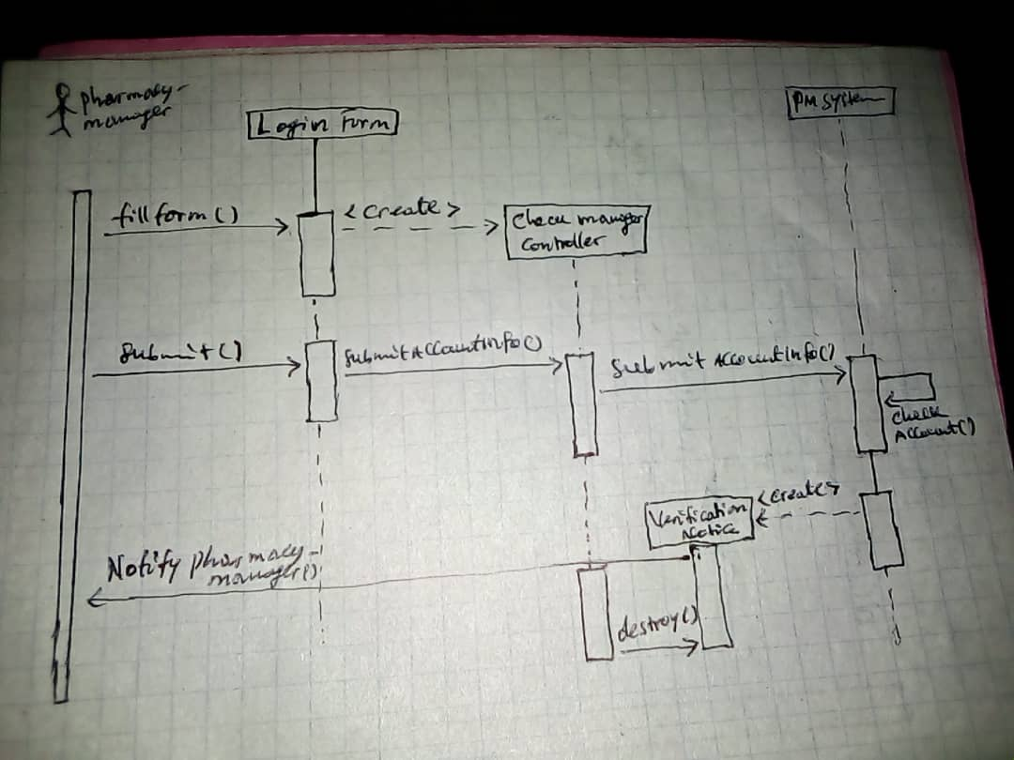

1. **Add new medicine data.**

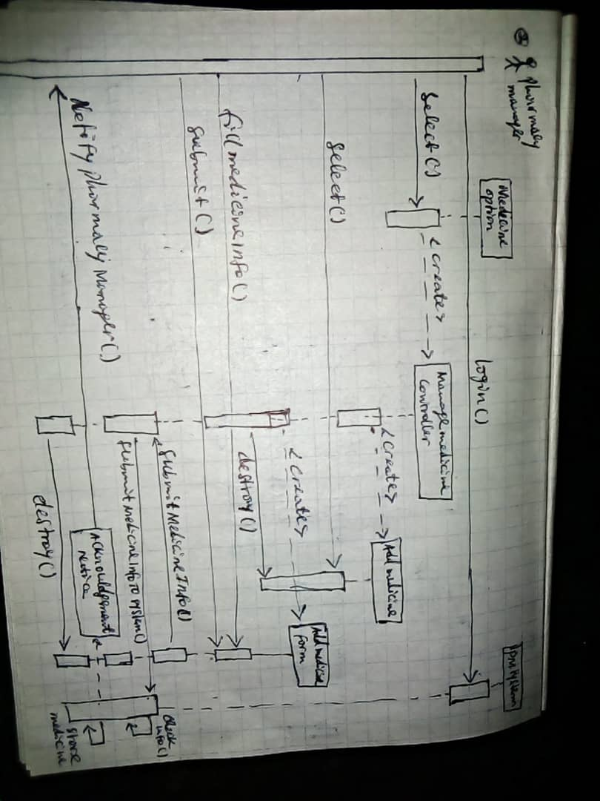

**3. Generate Report**

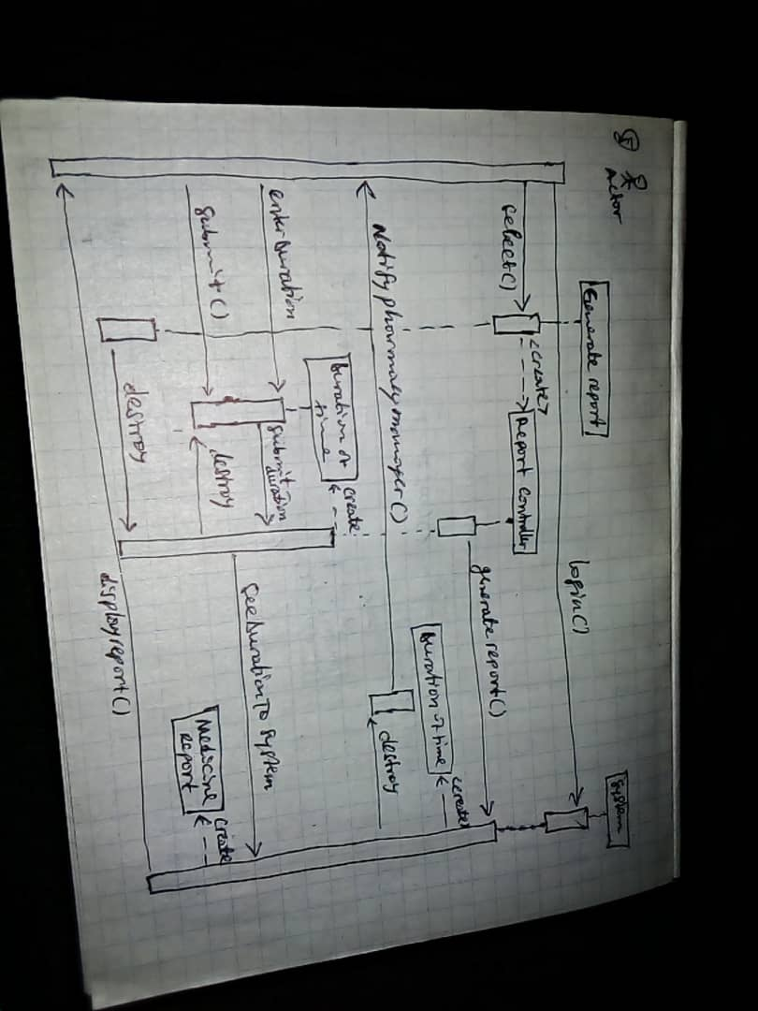

**4. Get Information about pharmacy**

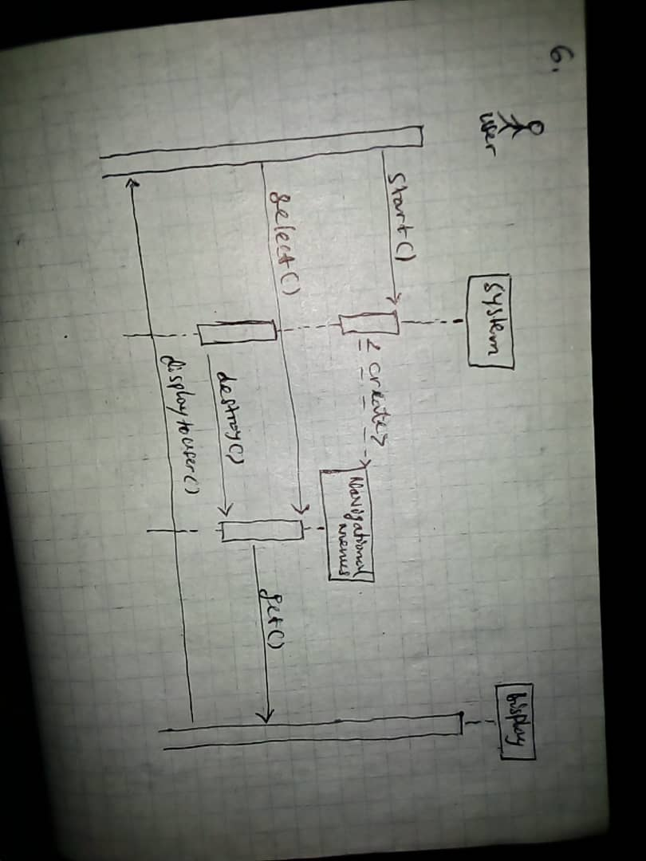

**5.Receive notification**

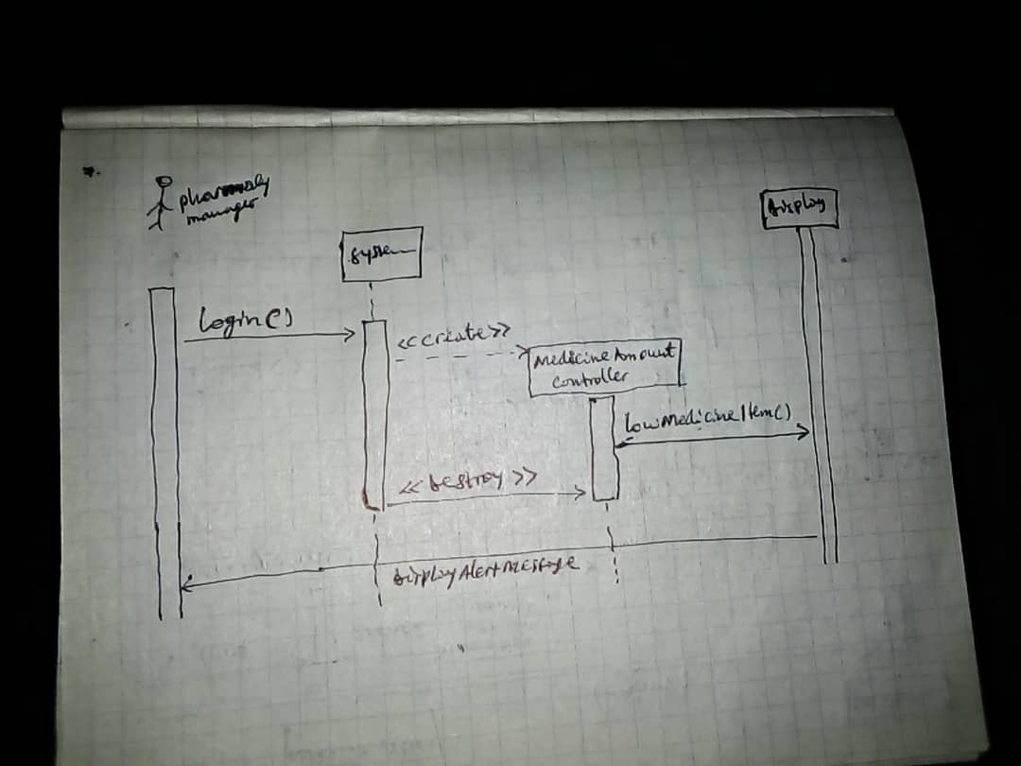

**6. Search Medicine**

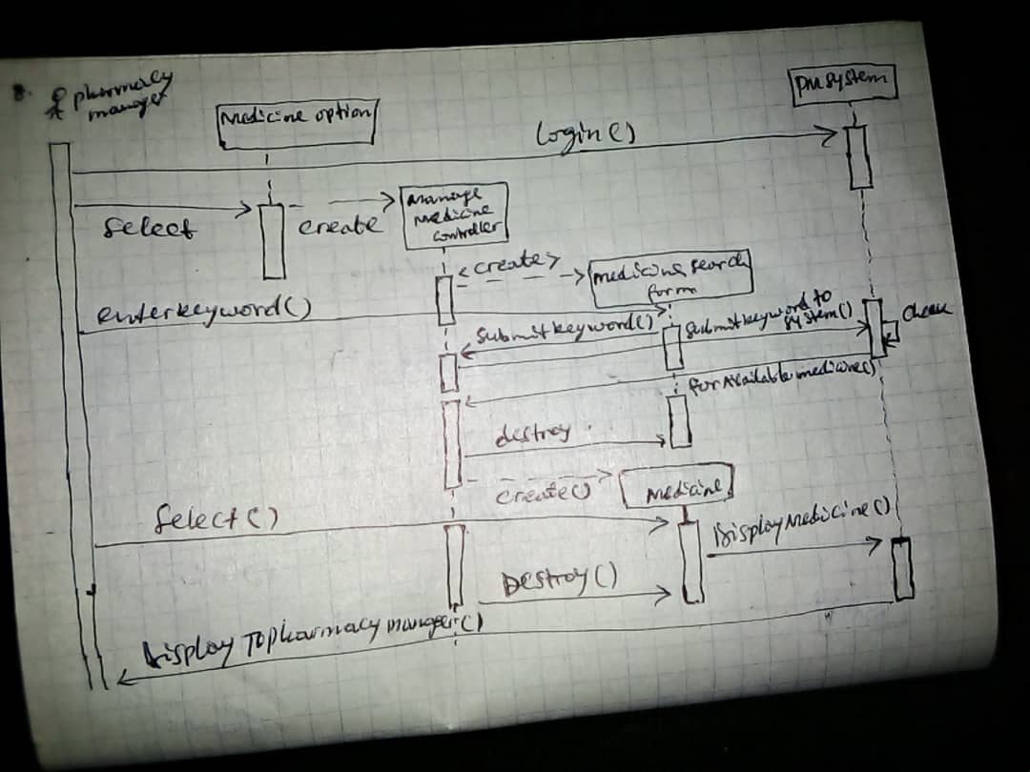

**7.See System instruction**

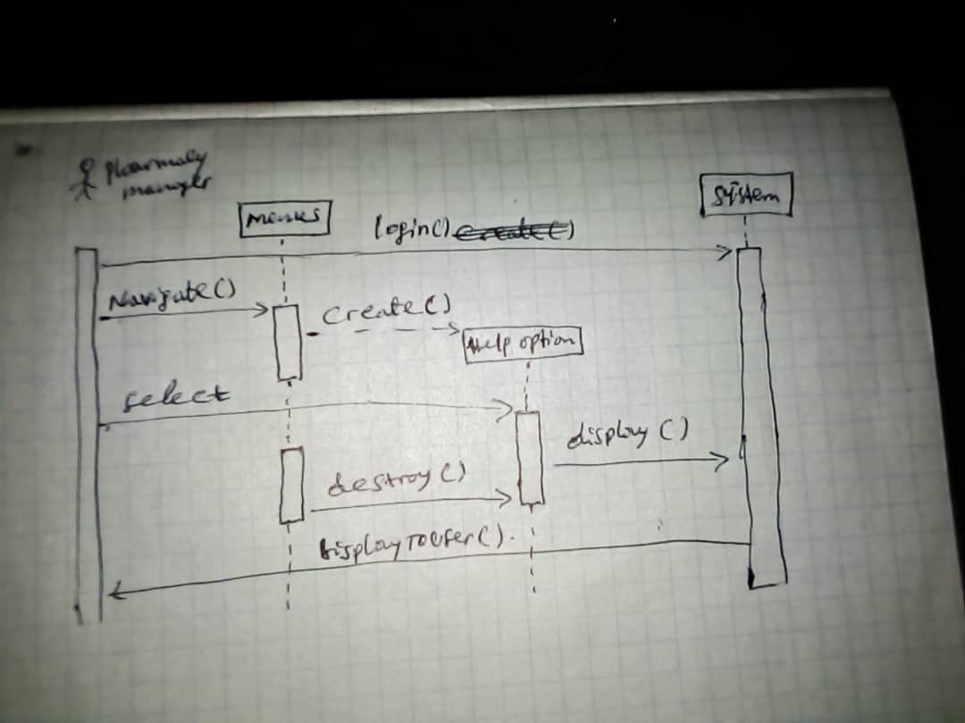

# 3.4.5. Supposed user interface

**REGISTER PAGE**

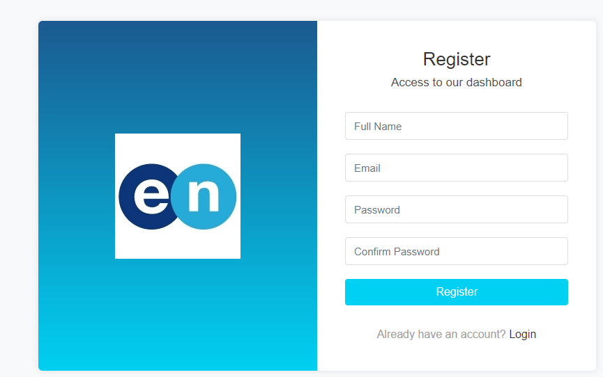

**LOGIN PAGE**

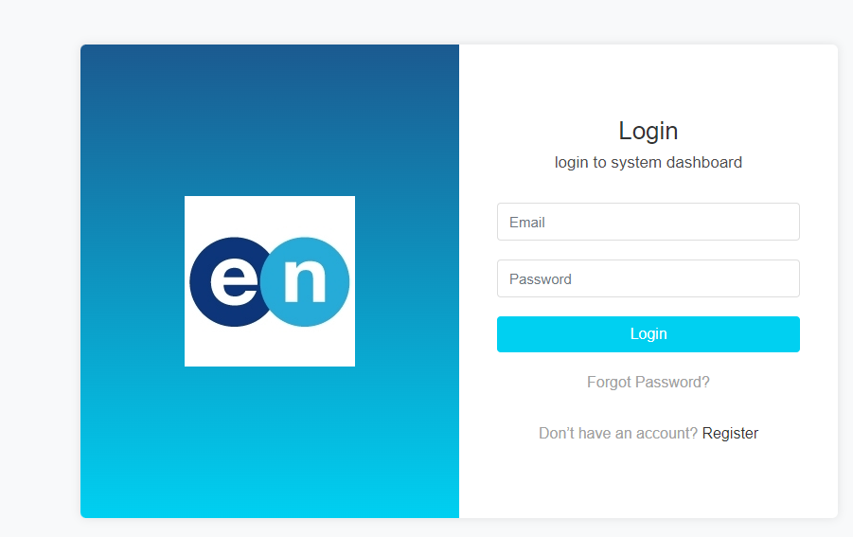

**ADMIN PANEL**

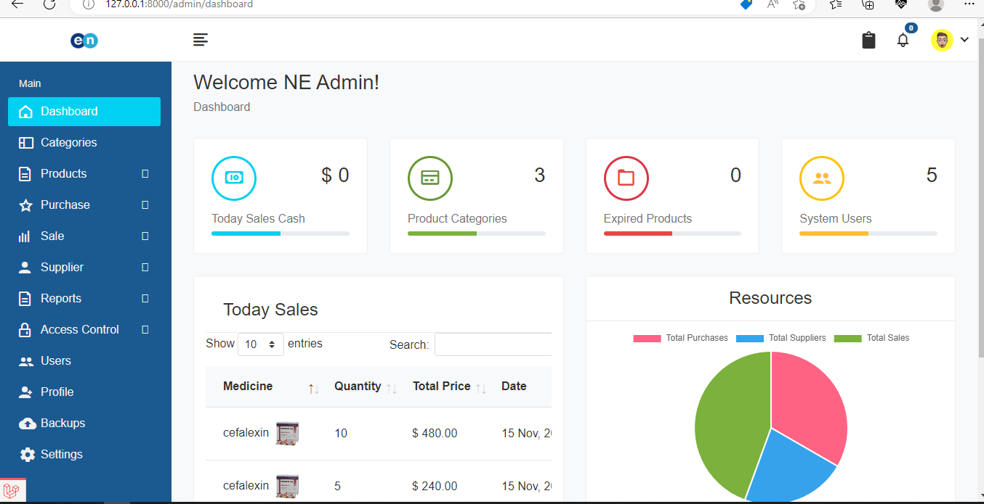

# 4. Glossary

1. Pharmacy Manager – Human who control the pharmacy management system.

2. Pharmacy management system- a computer system that stores the pharmacy data and

retrieves necessary information about medicines according to the user needs.

3. Sequence Diagram- a diagram which represents sequence of action that human or system

represents.

4. Use case- an action implemented by the computer system.

5. User interface- the computerized implementation of graphical user interface that represents

menu’s, frames and related components in one

6. Scenario- a short text description on the system function

**Github link:** <https://github.com/erikunda77>